# Conditional Probability and Independent events – Week 1

A person at a shop buys dog food.

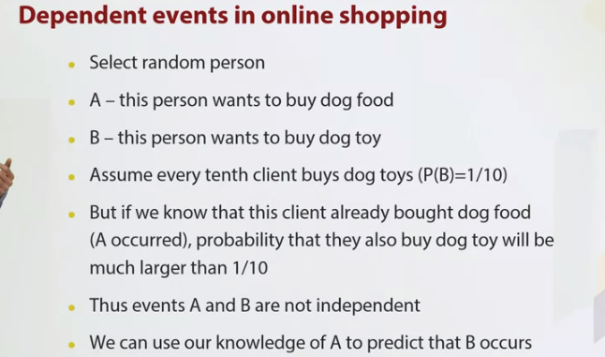

In supervised learning, we find some dependence is in the data, and predict something that we don't know using the information that we know.

In supervised machine learning, we are building predictive models that predict variance of some variable, using variance of some other variables. This is possible if there is some connections between these variables.

## Conditional probability

Example: Study how marriage is related to happiness in the following form. Only first 3 rows of 100 rows are shown.

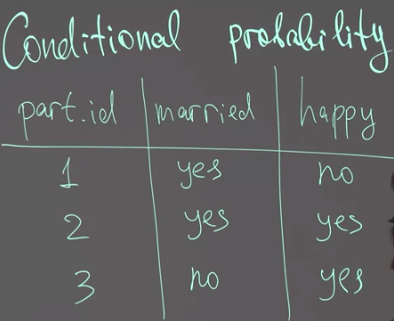

Contingency tables for this survey is given as

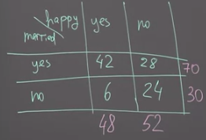

Now lets pick a random participant/row from the original table with equal probability.

Consider an even H and M. Lets consider the probability of happiness P(H) and that of marriage P(M).

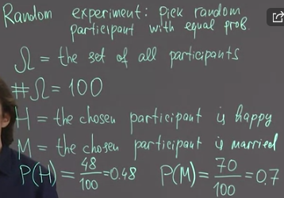

If I see a random person than his probability of being happy is 0.48, give that I don’t know if he is married. But lets say I see a ring in his finger, now P(H|M) is,

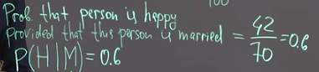

Now what is P(H|NotMarried) if the person is not married,



This is conditional probability and using this kind of relationship between variables allows machine learning algorithm to work.

### Definition of conditional probability

Therefore, the definition of conditional probability is given as follows,

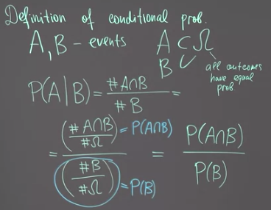

We can re-arrange this to give us a very important formula,

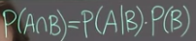

We can interpret this in the following way. B can either occur or not occur.

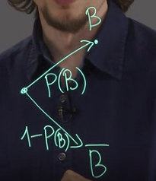

If B occurs then at the second line A should occur and that is how you get AnB. The as a result, the probability of AnB is P(B)*P(A|B).

## Independent events

Two events are independent if their conditional probability is the same as their probability. i.e. knowing the condition doesn’t give us more information.

Example, someone who has a dog likes cheese.

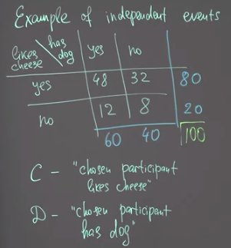

The probabilities are

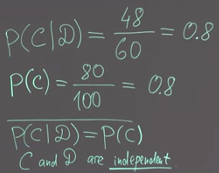

### Definition of independent events

In fact, all three conditions below are equivalent to each other, it means that, for example if condition 1 is satisfied, then condition 2 satisfied as well. Let us prove it, it is easy first to prove that condition 1 is equivalent to condition 3. Let us first proof that if condition 1 is satisfied, then condition 3 is also satisfied.

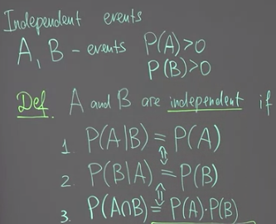

Take condition 1, from above we can insert the conditional probability equation in the middle. IF multiply both sides by P(B) we get,

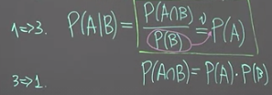

We can show the same for condition 2.

Let’s consider the dice tossing example,

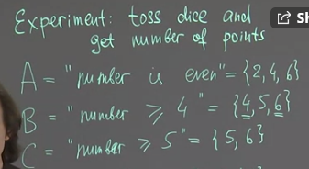

Given that B occurs, what is the probability of A given B?

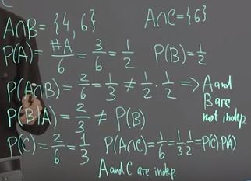

P(AnB) = P(A|B)*P(B) = 2/3 * 3/6 = 2/3 * 1/2 = 1/3

If A and B are independent then,

P(AnB) = P(A) * P(b) = 3/6 * 3/6 = 1/4

Therefore, intersection P(AnB)=P(A|B)*P(B) would be equal to intersection P(AnB)=P(A)*P(B).

## Mosaic Plot. Visualization of conditional probabilities and Independence

The mosaic plot shows the conditional probability – the intersection using areas on a rectangles. Consider the following example,

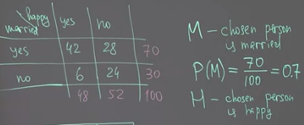

The probability space which contains 100 examples can be shown by a square. The probability of marrieds people = 0.7 can be show by the splitting this space. Obviously the 0.3 is the probability of people not married. Furthermore, the conditional probability P(H|M) is a 0.6 portion of the 0.7 area of this space.

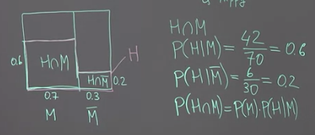

Independent events will have such a mosaic plot.

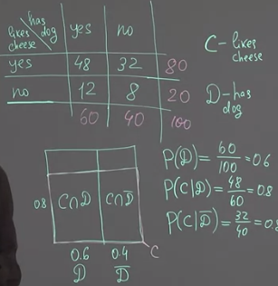

## Using independence to find probabilities - Examples

Often, we can assume that some events are independent from some general considerations and use this knowledge to find some probabilities.

Let us consider a professor who is going to the lecture. To go there, he have to drive through the city and it is possible to stuck in traffic if there will be traffic jam. To avoid traffic jams, Professor decides to depart earlier and so he has to set up some alarm clock. Unfortunately, alarm clock can fail. We want to find the probability with which Professor have to cancel their class.

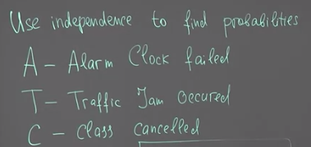

If both of these events occur, alarm clock failed, and traffic jam occurred, then unfortunately professor have to cancel the class. C is when both events occur. We know that alarm clock failure cannot cause traffic Jam so we can assume independence.

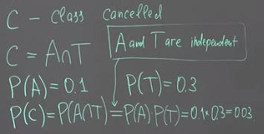

Another example: Let us consider a different example. Let us assume that we are a company that has to make some decision. For example, to buy or not to buy some start up. To make this decision, the company can ask expert is it good idea to buy this start up? Every expert can be wrong, so we can ask a number of experts.

So if both experts give the same advice, the probability that they both wrong is less than probability that only the first expert wrong. So in a sense, in this case committee of two experts is better than just one expert in terms of the error of mistake.

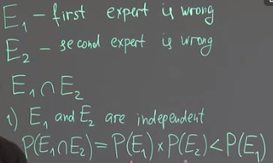

If one expert copy the other’s solution then, then the probability is higher.

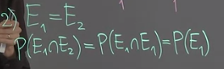

In fact, we use the same idea in machine learning. If we have several predictive models that make independent predictions, we can unite these models and create a new model which is called ensemble. If our models behave more or less independently to each other, the performance of ensemble will be better than the performance of one model.

## Pairwise and mutual independence

So far we discussed notion of independence for two events. However, when we have three or more events things becomes a little bit more difficult, and we have different notions of independence in this case. Example,

R1=R2 means the result of the first tossing is equal to the second tossing.

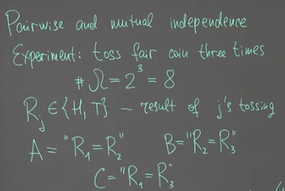

Now for P(A) and P(B) we have,

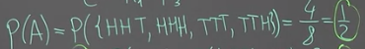 and 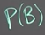

Now the intersection,

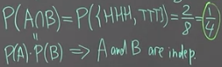

The probability equals to 2/8, which is 1/4. Is it true that A and B are independent? We see that probability of intersection equals to product of probability of A and probability of B.

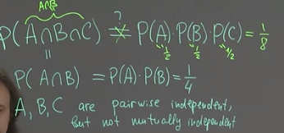

We can interpret this result as a kind of dependence between C and both events A and B. In this example, we have so called pairwise independence, meaning that all these three events pairwise independent. We see some dependencies between them. In this case, this dependence can be understood as the effect that if A and B occur, then C occur probability 1. In this case we say that we don't have mutual independence between these three events.

For events to be mutually independent, two conditions must be met,

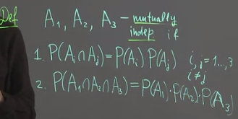

## Bernoulli Scheme

We will model the sequence by sequence of coin testing. However, now, this is not a fair coin, but some unbalanced coin for which probability of head is different from probability of tail. We assume independence between coins tossing since the coin has no memory.

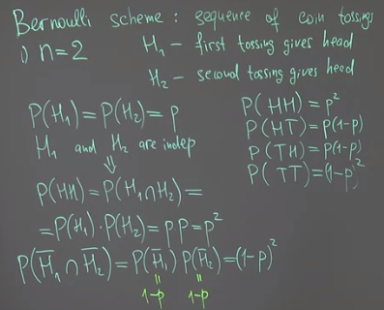

We can define the Bernoulli scheme as, note that the an arbitrary outcome is given by O.

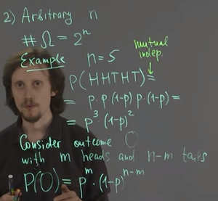

Thus we fully define Bernoulli's scheme. So we described the probability space and described the probability of every outcome in this probability space. Bernoulli's scheme is a very popular way to model processes in real life.

## Law of total probability

In our life, we have to make a lot of decisions. For example we have several schools and we have to decide which school to visit or we have to choose which book to read at some particular moment of time, and these decisions can affect probabilities of various events. For example of getting a particular job. We can use a probability theory to model to some extent this kind of relations between events, like choosing of school and getting a job. Let us consider one prominent example of this kind of reasoning which is called law of total probability.



First, the student can belong to first, second, or third year of education.This event is denoted by H_1 and the same events can be denoted H_2 and H_3 for second and third years. So H_2, H_3, similarly and assume that we know their probabilities. Then we are interested in knowledge of calculus. So event C is that student knows calculus.

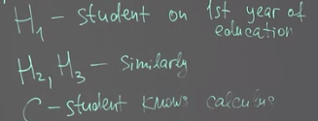

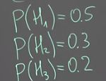

Note also that student cannot belong to two years at the same time. So H_i and H_j does not intersect each other if i is not equal to j. The union of all these three events is full probability space. i.e. we can only choose one. It is an OR (alternatives) probability. These events are usually called hypothesis. They actually generate some kind of partition of all probability space into some non-overlapping areas

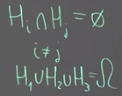

Also, the probability of a student knowing calculus is as follows,

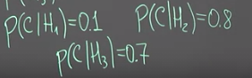

What we want to do is to combine this information to get probability that simply randomly chosen student knows calculus. So we are interested in the probability of this event C. The red square is the full probability space.

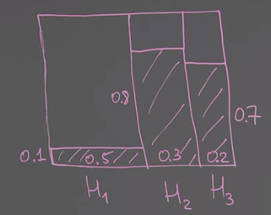

We have to find areas of all these smaller rectangles – hashed, and then sum them up.

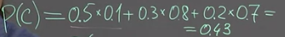

The general formula is for total probability is given as,

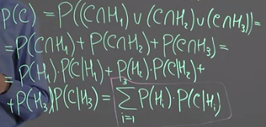

Provided that we know these probabilities. It is interesting to consider an inverse question. Assume that we know that event C occurred. So assume that we know, for example, that randomly chosen person knows calculus. What is the probability, for example, that this person is from the first year? So it is interesting to find the probability of hypothesis provided that these events halt. To find it, we have to use Bayes rule.

## Bayes's rule

Baye’s rule allows us, to in a sense, inverse these conditional probabilities. For example, let us find probability of H1 provided that C acute. It means that we picked random student and we found that the student knows calculus. What is the probability that the student is first-year student?

We can use the figure of the total area,

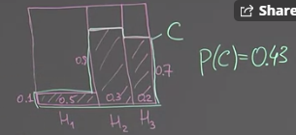

What is the proportion between the area of intersection, H1, nC. So this rectangle and the whole C, so this thing. P(H1) is the prior probability and P(H1|C) is the posterior probability.

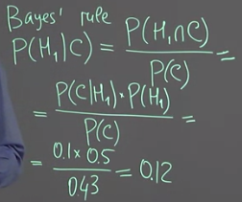

This is used in Bayesian statistics and in some branches of major learning.

In probability theory and statistics, Bayes’ theorem (alternatively Bayes’ law or Bayes’ rule) is a result that is of importance in the mathematical manipulation of conditional probabilities. It can be derived from the basic axioms of probability.

Mathematically, Bayes’ theorem gives the relationship between the probabilities of AA and BB, P(A)P(A) and P(B)P(B), and the conditional probabilities of AA given BB and BB given AA. In its most common form, it is:

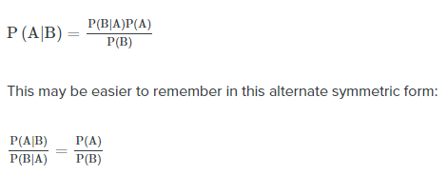

Example 1,

Another way to look at the theorem is to say that one event follows another. Above I said “tests” and “events”, but it’s also legitimate to think of it as the “first event” that leads to the “second event.” There’s no one right way to do this: use the terminology that makes most sense to you.

In a particular pain clinic, 10% of patients are prescribed narcotic pain killers. Overall, five percent of the clinic’s patients are addicted to narcotics (including pain killers and illegal substances). Out of all the people prescribed pain pills, 8% are addicts. If a patient is an addict, what is the probability that they will be prescribed pain pills?

Step 1: **Figure out what your event “A” is from the question.** That information is in the italicized part of this particular question. The event that happens first (A) is being prescribed pain pills. That’s given as 10%.

Step 2: **Figure out what your event “B” is from the question.** That information is also in the italicized part of this particular question. Event B is being an addict. That’s given as 5%.

Step 3: **Figure out what the probability of event B (Step 2) given event A (Step 1)**. In other words, find what (B|A) is. We want to know “Given that people are prescribed pain pills, what’s the probability they are an addict?” That is given in the question as 8%, or .8.

Step 4: **Insert your answers from Steps 1, 2 and 3 into the formula and solve.**  
P(A|B) = P(B|A) * P(A) / P(B) = (0.08 * 0.1)/0.05 = 0.16

The probability of an addict being prescribed pain pills is 0.16 (16%).

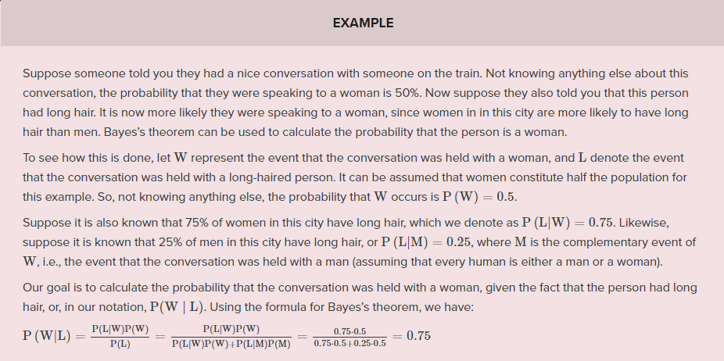

Example 3,

1% of people have a certain [genetic defect](https://www.genome.gov/10001204).  
90% of tests for the gene detect the defect (true positives).  
9.6% of the tests are [false positives](https://www.statisticshowto.com/false-positive-definition-and-examples/).  
If a person gets a positive test result, **what are the odds they actually have the genetic defect?**

The first step into solving Bayes’ theorem problems is to assign letters to events:

A = chance of having the faulty gene. That was given in the question as 1%. That also means the probability of *not* having the gene (~A) is 99%.

X = A positive test result.

So:

P(A|X) = Probability of having the gene given a positive test result.

P(X|A) = Chance of a positive test result given that the person actually has the gene. That was given in the question as 90%.

p(X|~A) = Chance of a positive test if the person *doesn’t* have the gene. That was given in the question as 9.6%

Now we have all of the information we need to put into the equation:  
P(A|X) = (.9 * .01) / (.9 * .01 + .096 * .99) = 0.0865 (8.65%).

The probability of having the faulty gene on the test is 8.65%.

# Random Variables – Week 2

A random variable is a variable whose value is unknown or a function that assigns values to each of an experiment's outcomes. Random variables are often designated by letters and can be classified as discrete, which are variables that have specific values, or continuous, which are variables that can have any values within a continuous range.

Example of random variable which is integer.

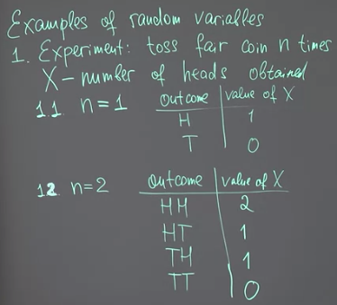

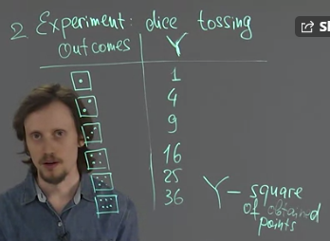

Example of random variable being float – sum of two coins,

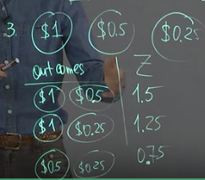

## Mathematical definition of random variable

From a mathematical point of view, the following function is described just by this set of numbers. And we can introduce different random variable by specifying different numbers here.

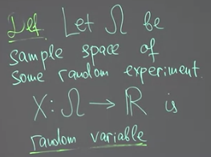

i.e X is a random variable and it is a real value from the omega space.

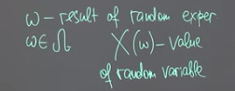

If we conduct the same experiment several times, for each time we have its own omega small, its own outcome and its own value of random variable. In this case, we can say that we sample our random variable. And during this sample, we get just a sequence of some numbers.

## Probability distribution and probability mass function (PMF)

We can summarize the values of the random experiment we previously conducted and calculate the probability of events.

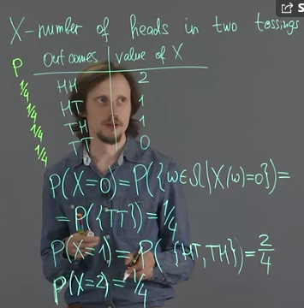

We can summarise the probabilities as,

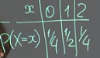

This table is called the distribution of x. It has the probability of each value in the random variable.

Now we can answer question such what is the probability of an even equal and bigger than 1?

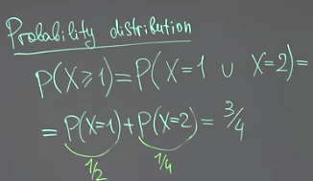

The distribution of random variable X can be defined as,

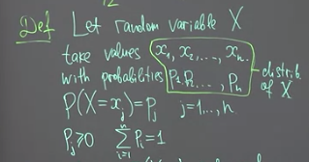

Two pair of sequences for x and p values circled are called distribution of random variable X given that the sum of all probabilities equals to 1.

Another notion that is useful tool to describe the distribution in mathematical convenient way is this thing called probability mass function (PMF).



This function for our example can be plotted as,

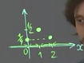

This is not a continuous function as it only has values at 0, 1, 2.

## Binomial distribution

Binomial distribution is a distribution of random variable that counts the number of heads in n tossings of a coin that is not necessarily fail. So our random experiment is to toss n times a coin that not necessarily fair.

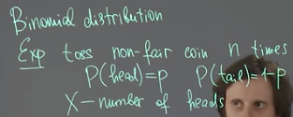

Example with n=5, lets create the distribution table of X. P(X=0) means 5 tails in a row and all tails are independent of each other, therefore, the probability of all five tosses is P(HTTTT) = p(1-p)^4 i.e. independent with no conditionality.

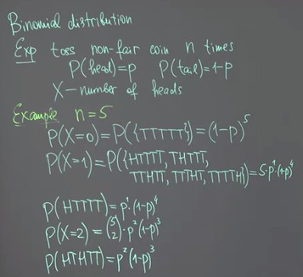

The general case is given as,

The binomial coefficient n choose k times p_k times 1 minus p to the power n minus k. Here, this value is number of outcomes with exactly k heads. Indeed, this number is the number of ways to choose k elements out of n.

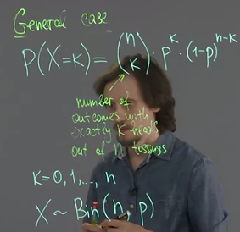

## Expected value of random variable

What value a random variable takes on average? What does it mean on average? You know that if you have some finite number of values, we can find the average of these values by finding there sum and dividing by the number of these values. But for other variables, this method doesn't work in general. Because we have to take into account that some values of random variable are taken with large probabilities. And other values are taken with low probabilities. It is natural that those values with large probabilities will contribute more to the average value. The easiest way to think about average of random variable is to think about average win, average payout in some kind of lottery.

It is a random variable, and we have only two possible values for X. Either Bob can win $5, and this happens with a probability 0.1, one-tenth. Or Bob can lose $1, And this happens with probability of 0.9, nine-tenth. The question we're interested in, what is an average payout of Bob? To find this average payout, let us assume that Bob plays a lottery many, many times. Let us assume that Bob plays, for example, 10,000 times. What is Bob’s payout for each game.

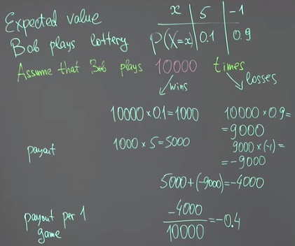

It is -€0.4.

We can rewrite this in a different way,

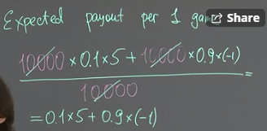

We can define the general case or expected value as,

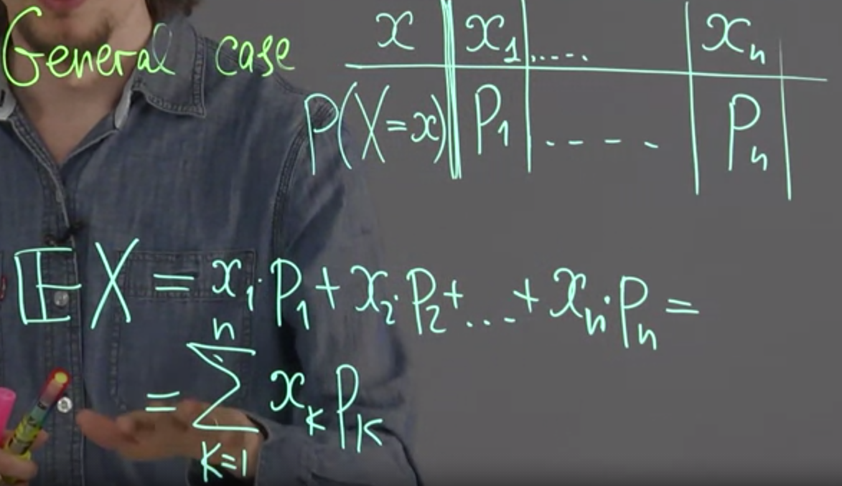

If Pk is constant then this is just the normal average, otherwise the expected value of X is the weighted average of xk and pk, where xk is the count of an event like the count of states in a feature of my dataset and pk is its probability which is this xk divided by the length of the feature.

Example

Consider the roulette problem where we bet 100 on red. Now Red and the value of 100 is interchangeable when creating the distribution table.

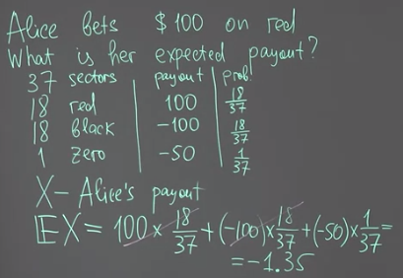

Alternatively we can write this differently and can give us a formula.

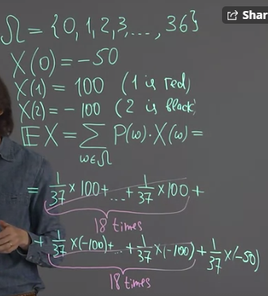

## Expected value as best prediction

One of the basic problems to machine learning is prediction problem. We have some information. We know something and we want to use this information to predict some quantity that we don't know.

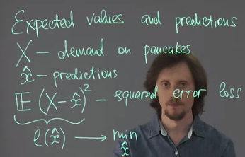

Our prediction can be good if we are lucky enough and on the other day for example we have demand which is much larger than we predicted, just due to chance and we have large value of this loss. What we usually want is to make our predictions good at average. It means that we have to find an expected value of this loss. Now this value is not a random variable because we have expected value here. This is just a number that depends on x hat. Let me denote this number as L of x hat. L stands for loss. Now our goal is to minimize on this function L of variable x hat by choosing appropriate x hat.

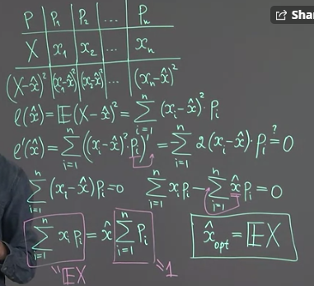

This is a really important result. If you want to predict the value of a random variable, and have squared error loss, then you can chose expected value of this variable as your prediction. This is a simple example of prediction i.e. you predict the value of your random variable using as the expected value.

## Variance of random variable

To measure how far another variable deviates from its expected value, we will use variance.

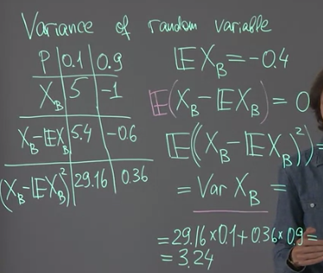

Note that variance is nothing but the loss which we used above to derive the value of expected value. We minimized this loss by taking the derivative of the loss and set it equal to zero. This loss (or variance of Xb) is the best or minimum value we can get for this problem. To generalize this,

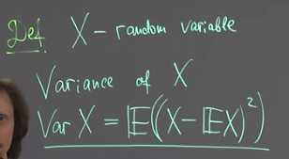

We use variance to show that their values are close to expected values.

## Discrete random variables with infinite number of values

So far we considered only random variables with finite number of possible values. However, it is possible that we deal with some phenomena in which the corresponding variable can take infinite number of values.

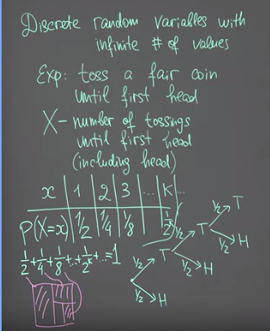

Comparing random variable with finite and infinite values we can show the following,

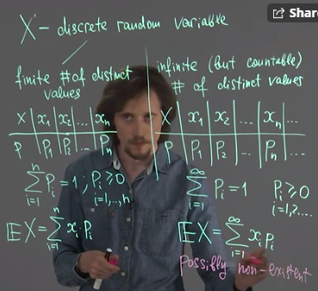

Note that n is now replaced with infinite.

Example of Geometric and Poisson distribution are,

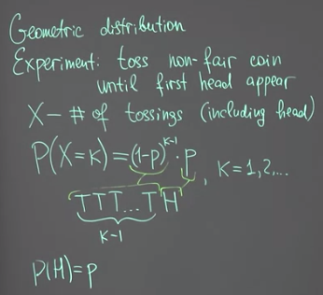

Example of Poisson distribution is: What is the probability of getting K customers in a day i.e. X=K when the average number of customer in a day (lambda) is given.

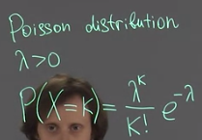

# Systems of random variables – Week 3

## Linear transformations of random variables

What does it mean that it is a system? These two variables can interact with each other. It means, for example, that if we know something about X, we can say something about Y and vice versa.

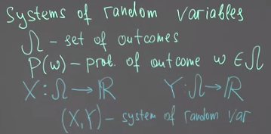

You can create a new random variable using X by adding 2 or multiplying X by 2, which gives us Y and Z.

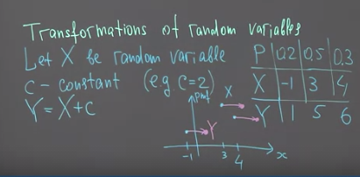

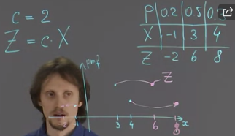

Such transformations change the probability mass function (PMF) of the random variable X. In addition it shifts the pmf to right and with multiplication it stretches the pmf.

## Linearity of expected value

How does the expected value changes after transformation? It simply changes by c.

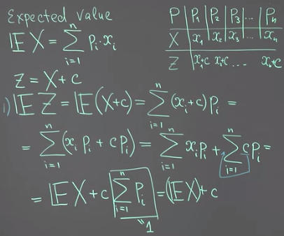

How does it change with multiplication? It is simply multiplied by c.

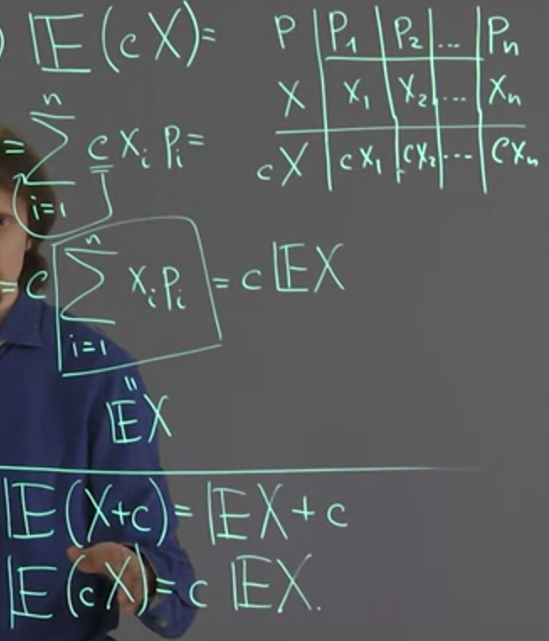

## Symmetric distributions and their expected values

symmetric distribution that has probability mass function using some vertical axis of symmetry. The expected value is X0.

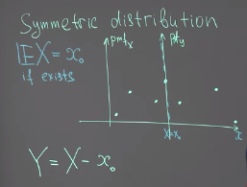

Let’s consider new variable Y to prove that X0 is the expected value,

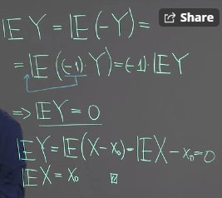

## Properties of variance

Variance does not change when we add a constant to random variable.

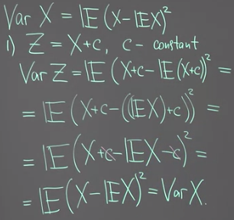

For multiplication the change in variance - equal to c squared times variance of X.

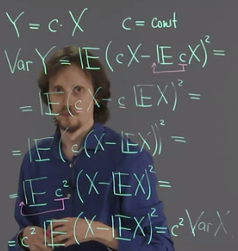

## Sum of random variables

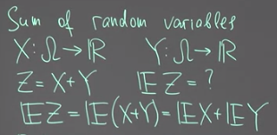

For variance



But for some special case they can be equal.

## Joint probability distribution

To describe interactions between random variables, we have to introduce a new notion, the notion of joint probability distribution.

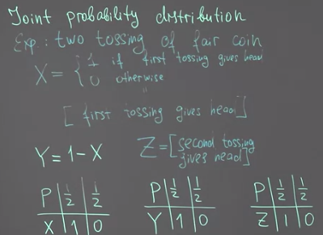

Now if we look at these three probability distributions, we don't see any difference between these three random variables. But if we think about pairs of these random variables, we see the difference. For example, what is the probability that X equals to zero and at the same time Y equals to zero? This probability is equal to zero

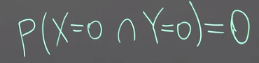

What is the probability that X equal to zero and at the same time Z equal to zero?

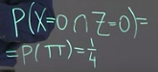

So we see that similar questions that are asked to the pair of X and Y and the pair of X and Z gives different answers. This showsus that despite the similarity between their probability distributions, these variables are in some sense distinct. To show this distinction we introduce joint probability.

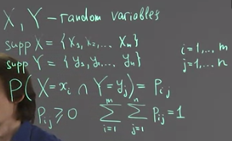

Support (supp) of X is just a set of all distinct values that X can take. The probability Pij together with this supports gives us the probability distribution which is called joint distribution of two variables X and Y. The joint probability can be presented by this table,

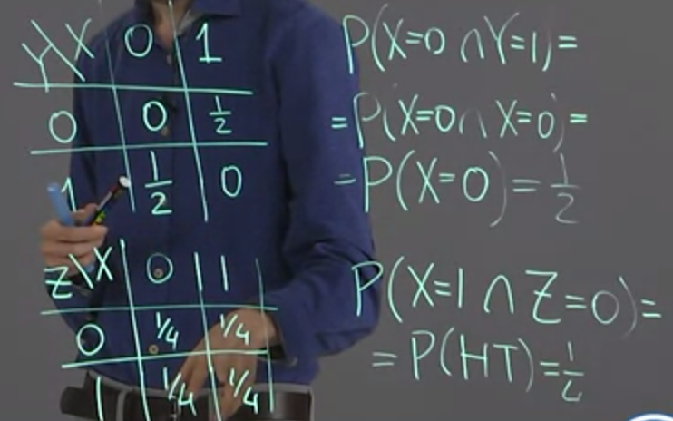

## Marginal distribution

Joint distribution of two variables gives us information about a distribution of both of them. But what if we are interested only in one variable? You simply sum across the row or columns the probabilities and the final value is that probability. For example, if we want to find marginal distribution of X we sum the first columns,

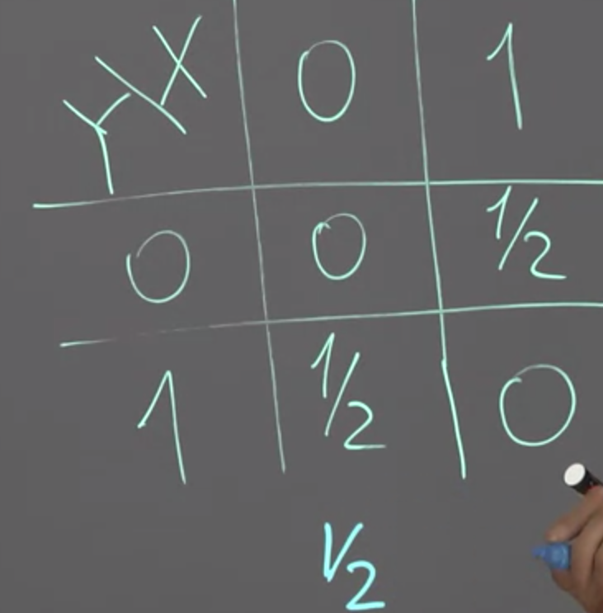

If you want the marginal distribution of Y then you sum across the rows.

We can prove that this probability is equal to sum of the probabilities of this kind. Let me denote these probabilities by Pij. Then this probability is equal to sum, Of Pi 1 +, and so on, + Pin. Or in different notation it is the sum like this one. (U is the union).

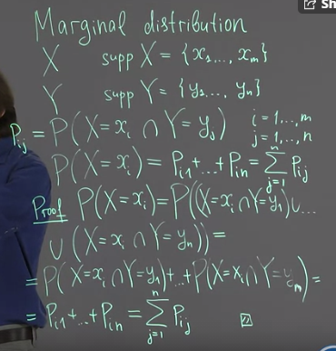

so it means that that in general, if you know marginal distribution, you cannot extract joint distribution of two variables, because you don't know how they interact with each other. However, if you know that two variables are independent of each other. Meaning that if you know something about the value of one variable, you don't know anything new about the value of other variable. Then you can extract joint distribution just by looking at these marginal distributions

## Independent random variables

If the conditional probability of Yi given Xi is equal to probability of Yi then X and Y are independent or if their intersection is multiplication of their probabilities.

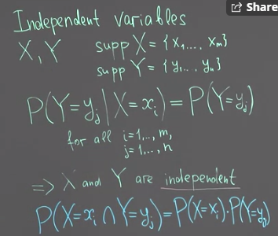

You can simply look at the joint probability table. Z and X are independent.

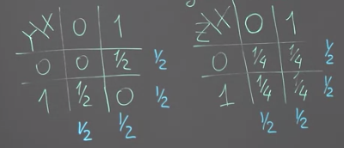

Another example,

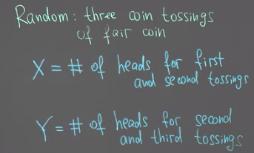

Now to check if these random variables are independent, we have to answer, for example, is it true that the value in the first cell (1, 1) value is equal to product of summation across the row and the column. That is not true i.e. 1/8 not equal to 1/4x1/4.

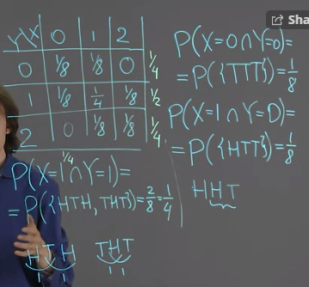

This is an example of a situation when two variables are not independent, but they are not in deterministic dependence between each other. The dependence between them is a kind of probabilistic.

## Expected value of product of independent random variables

We discussed that expected value of sum of two random variables is equal to sum of expected values. But for example, for product of expected values, it is not true. However, if two random variables are independent, then a very natural relation between expected value of their product and product of expected values takes place.

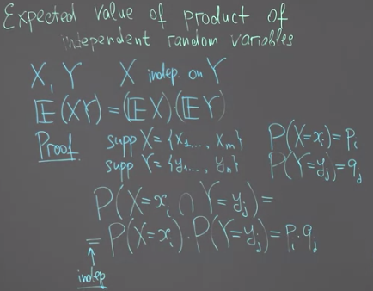

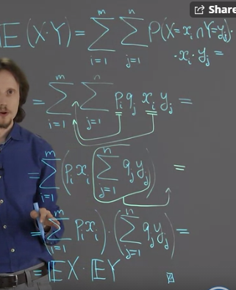

## Variance of sum of random variables. Covariance

Previously, we found that variance of sum of two random variables is not necessarily equal to sum of variances. However, it appears that if two random variables are independent, it is true that variance of sum is equal to sum of our answers. To prove it, first, we have to prove an additional Lemma, and this proof also introduce a notion of covariance of two random variables.

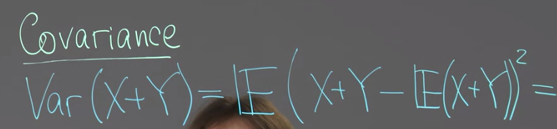

we can use property that expected value of sum is equal to sum of expected values and rearrange downs in this sum.

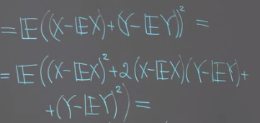

Now, we can use the rule that expected value of sum of these three random variables is equal to sum of their corresponding expected values.

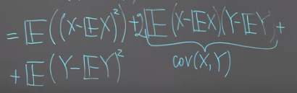

If two random variables are independent then their covariance is zero.

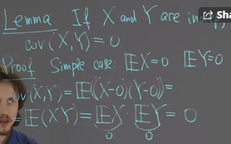

For the general case, this would slightly be more complicated but the idea is the same,

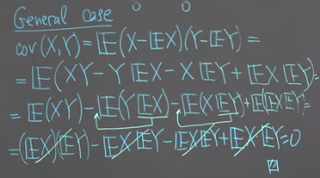

Variance of x plus y, is equal to variance of x plus variance of y.

## Properties of covariance

From above we have,

1. Var(X+Y) = VarX+VarY+2*Cov(X, Y)
2. X and Y are independent if Cov(X, Y) = 0
3. If Cov(X,Y)=0 it is not necessary that X, Y are independent
4. Cov(X, Y) = Cov(Y,X)
5. Cov(X+c, Y) = Cov(X, Y)
6. Cov(cX, Y) = cCov(X, Y)
7. Cov(X, kX) = kCov(X, X) = kVarX

## Correlation of two random variables

Covariance gives us some information about relation between two variables. There is another coefficient that can be used for similar objective, but has a little bit different and in some cases a little bit better properties. This coefficient is called correlation.

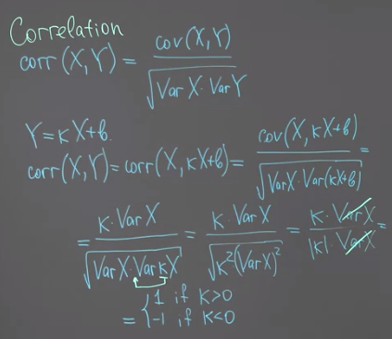

Properties of correlation,

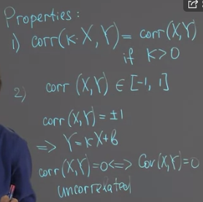

# Continuous random variables – week 4

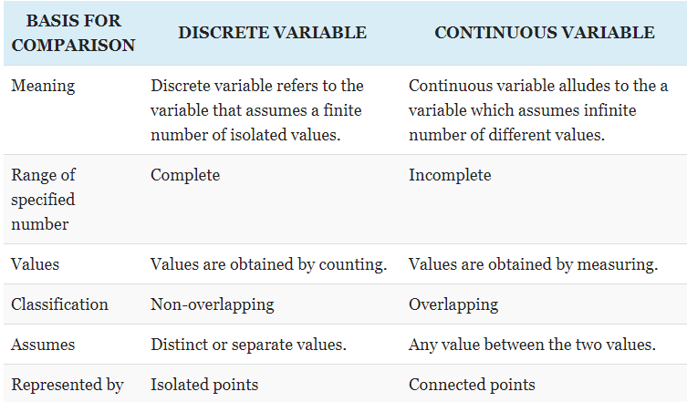

## Introduction

Types of variables,

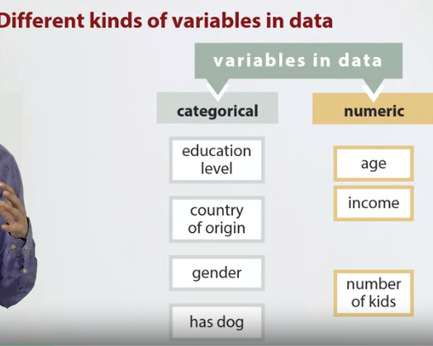

In most of cases, we have to record this categorical data in numeric. We have only particular values like 0, 1, 2, and so that can be taken with some probabilities. However, if we consider, for example, income we cannot use discrete random variable to model it.

## Continuous random variables

iscrete random variables into two sub-categories, random variables that can take only finite number of values. In this case, to specify a random variable, we specify its distribution, meaning that we specify which values this random variable can take and with which probabilities. So we have X_1 and so on, X_n. This is values and P_1 and so on, P_n probabilities. Another option for discrete random variable is to take infinite many but countable numbers of values.

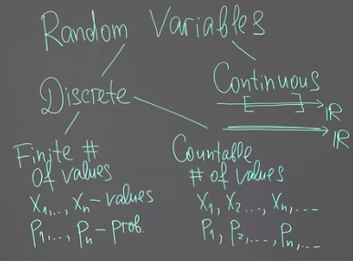

Can we describe continuous variable in terms X and P as we did for discrete variables?

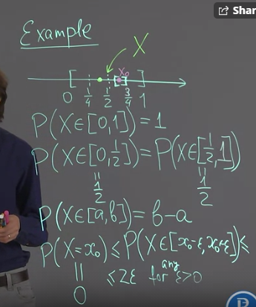

No we cannot describe continuous variable in terms X and P as we did for discrete variables, because the probability P(X=x0) = 0.

However, we can use a different notion, a notion of probability density function, to describe continuous random variables.

Mathematically speaking, it is possible to consider more complicated random variables other than discrete and continuous.

## Probability density function (PDF)

As we discussed before, it does not make sense to ask about continuous random variable, what is the probability that this random variable takes a particular value? However, we can ask what is the probability that our random variable takes a value which is close to some particular number?

How can we ask mathematically about the probability that our random variable takes the value that is close to this x0. We can consider some small segment that is nearer to x0. For example, segment from x0 to x0 plus Delta x where Delta x is some small number.

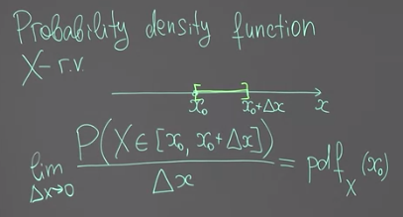

The probability over a short distance can become too small. What we can do is divide it by deltax. If the limit exist then this probability divided by deltax is the pdf at a x0.

Consider the example. X0 can be between 0, 1 or outside it.

In the first case, probability that our random variable x is inside of this segment is equal to its length and its length is Delta x. So probability that x is inside x0, x0 plus Delta x is equal to Delta x. A probability density function can be defined as a limit.

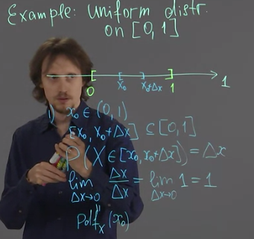

The pdf at x0 is 1, thus the function when plotted looks like this.

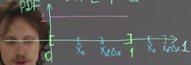

the second case when x0 is outside of segment from one to zero can be treated similarly. What is the probability for our random variable to be inside some segments from x-naught to x0 plus Delta x, if is outside of this segment. By definition our random variable takes values only on this segment. It means that the probability for our random variable to take value here is equal to zero. It means that if we consider definition of probability density function, we will also have zero.

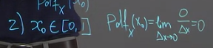

What about these points; zero and one? It appears that probability density function is not defined at this point because this limit does not exist, but this is perfectly normal.

So far, we defined a probability density function for uniform distribution. At uniform distribution, all parts on the segment have the same probability provided that they have same length, and this can be seen by the fact that the probability density function is constant over this segment.

## Cumulative distribution function (CDF)

Together with probability density function, we need yet another one way to describe continuous random variables. This way is called to use cumulative distribution function.

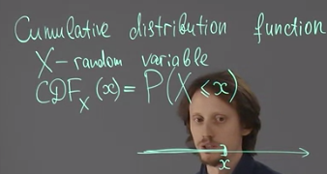

Let X be some random variable, and let us consider the following function. Its value from some point x is probability that our random variable X takes value that is less than or equal to x small. So basically, if we have some point here x, then we have this ray from x to negative infinity, and CDF of x is the probability that X capital is somewhere inside of this range.

What is the probability that our random variable uniformly distributed on this segment has value that is less than zero at the dot point to the left of zero. The CDF is equal to zero.

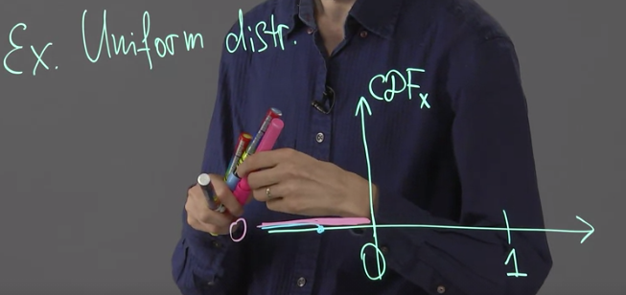

Now, let us consider some point to the right of 1. So this happens with probability of one. It means that for all points to the right from 1, the corresponding CDF is equal to 1.

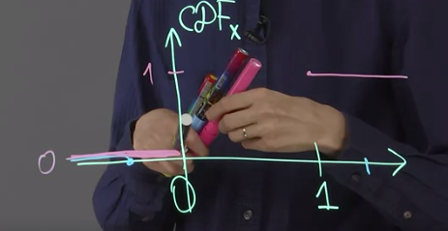

What about the points between 0 and 1, for example x0?

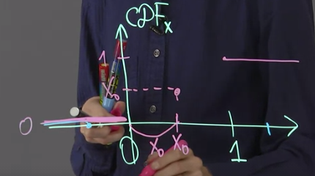

Since the probability is equal to the length of x0, then it is x0. Therefore we can connect the CDF values for x, x0 and 1 and form a linear function.

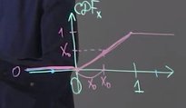

As a result the CDF is given as,

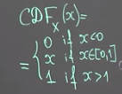

We can define cumulative distribution function not only for continuous random variables, but also for discrete random variables. For each point ahead the probability are cumulatively added.

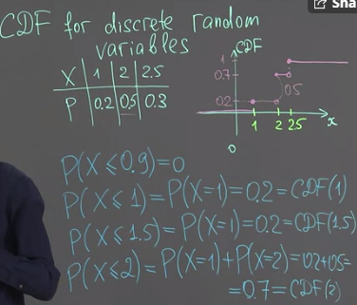

Cumulative distribution function can define random variables that are continuous and that are discrete. It is a kind of universal tool describe random variables.

## Properties of CDF

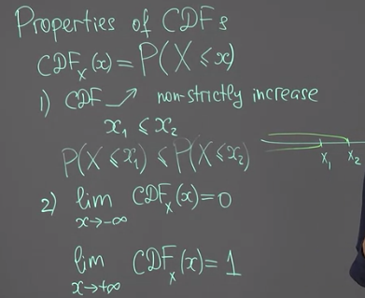

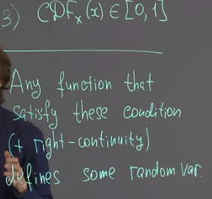

We will only consider only random variables that has probability density function. They are called continuous, or strictly speaking, absolutely continuous random variables.

## Linking PDF and CDF

Cumulative distribution function is mathematically convenient way to describe random variables. However, we are more interested in the probability density function because it is easier to interpret them. So it is important to discuss the relation between cumulative distribution function and probability density function. This relation is mathematically very nice.

Probability that X takes value in the segment [a, b] can be found as a difference between values of F at point b, and at point a.

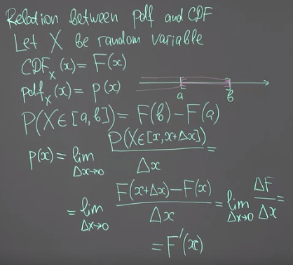

We see that probability density function is a derivative of cumulative distribution function. As a result, CDF can be by integrating pdf. This follows from the fundamental theorem of calculus.

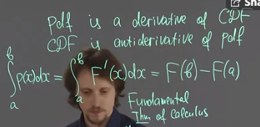

Example, if we have a pdf function, we can use the above formula we can find the area.

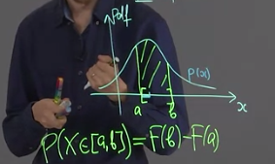

Let us consider some small segment. The probability that our random variable takes value in this segment can be calculated in the following way.

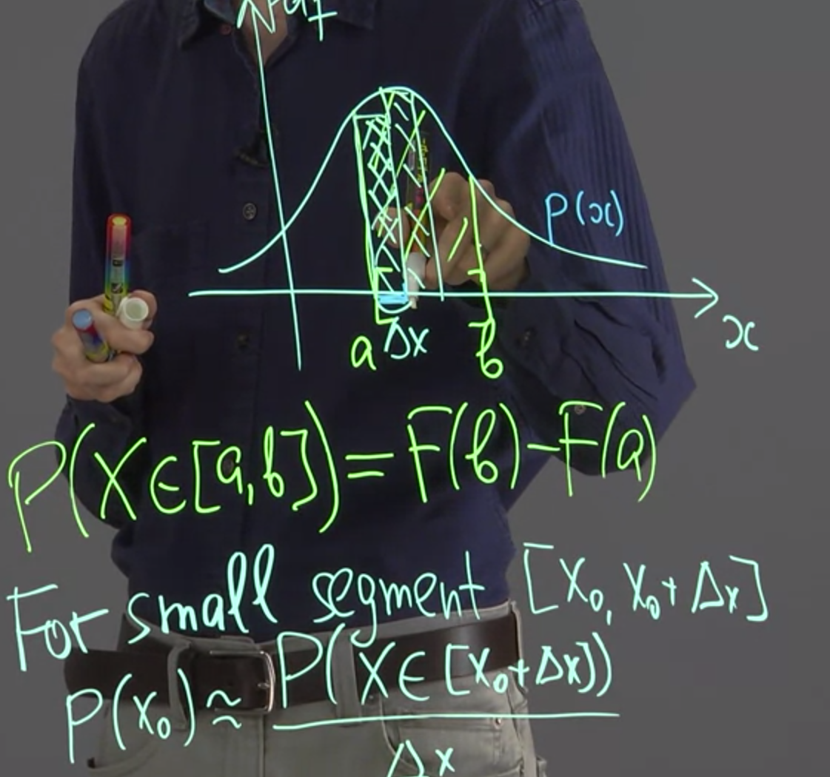

rom this relation, we can see that this probability is approximately equal to product of this probability density function and Delta x. So geometrically, if this is Delta x, then geometrically, this probability is equal to area of some rectangle like this one.

## Examples of probability density functions

Previously, we discussed only a uniform distribution on segment from zero to one, but it is possible to define similar distribution on any segment. Outside of this segment, the probability density function have to be equal to 0 because no points here or here are possible. Note that all probabilities summed must equal to 1, thus we can find Po.

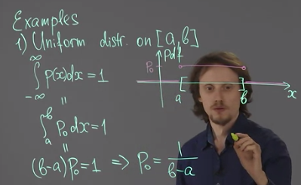

We can define probability of uniform distribution on arbitrary segment from a to b.

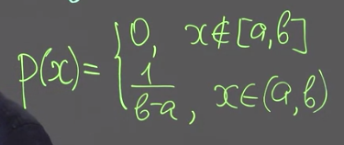

Second example. We can consider a non-uniform distribution on some segment. Let us begin with segment from zero to one. Let me assume that I want the distribution that gives higher probability to get a point near zero than near one. Let’s take a linear function.

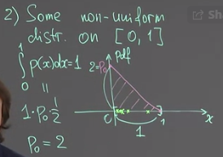

This is an example of non-uniform distribution on a segment.

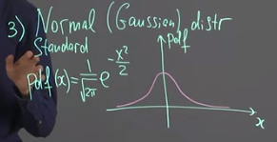

## Histogram as approximation to a graph of PDF

Let us assume that we have a random variable, but we didn't have access to its mathematical specification. We don't know its cumulative distribution function or probability density function. However, we can sample from this random variable. It means that we can take its values several times, and these values are independent of each other. In this case, we can estimate how probability density function looks like. This can be done by histogram.

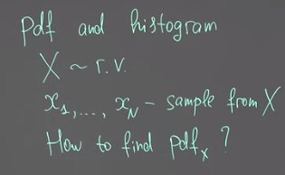

How to find the probability density function of X? We cannot do it exactly, but we can approximate this probability density function using this sample. The idea is quite simple.

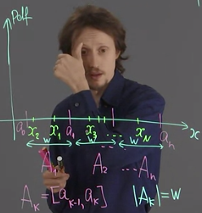

To do so, let us divide our horizontal axis to several segments. Theoretically, these segments (shown by a) should be small. But I don't want to draw a very small segments and use the large ones. Let us assume that the width of all segment is the same and it is equal to W. So we have W here.

First of all, let us calculate values f_k. They are called frequencies, and this is just a number of points x_i, for which x_i lies inside the segment A_k. For example, for this picture, f_1 is equal to 2, f_2 is equal to 3, and f_3 is equal to 1. Now, let us find relative frequencies. Relative frequency is equal to f_k over N.

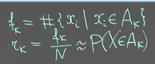

We can draw the following table,

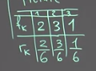

The pdf is given as,

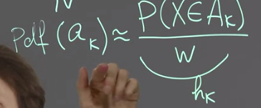

Note that the Y axis on the pdf plot does not represent the probability but it represents that probability divided by w.

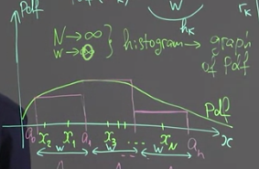

## Expected value of continuous random variable

Instead of summation, as we did for discrete variable, we have to use integration. Now, let us assume that x is continuous random variable, and instead of this distribution, x has probability density function p.

The two formulas as quite similar,

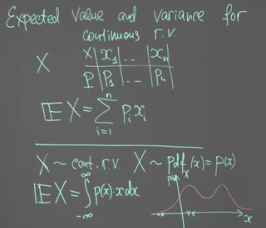

Now, to find the expected value of x, we have to integrate from negative infinity to infinity b of x times x, dx. However, p of x is equal to zero outside of the segment from zero to one.

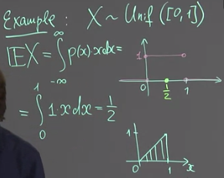

Actually, we can use the idea that we discussed before. If probability density function is symmetric, then the axis of symmetry have to be equal to expected value, if it exists.

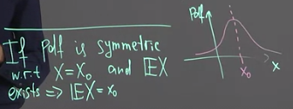

## Variance of continuous random variable - properties

When we defined expected value the variance will be defined exactly in the same way as for discrete random variables.

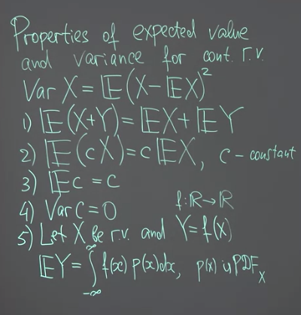

Lets consider the geometric meaning of variance. Consider two pdf for X and Y, where variance of Y is large therefore, pdf is wide.

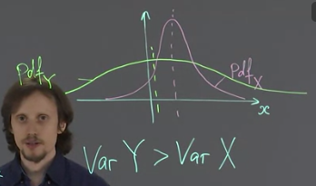

## Joint CDF and PDF. Level charts. Marginal PDF

If we have two random variables and are interested in interaction between them, we have to consider Joint distribution and Joint probability density function.

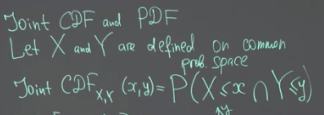

To visualize variance of two random variables, let us use Cartesian plane. We have two axis, x-axis and y-axis and random variable X takes values on this x-axis and random variable Y takes values on the y-axis. So the pair is denoted by some point on this Cartesian plane. Now let us consider segment here from x0 to x0 plus Delta x and some segment here,

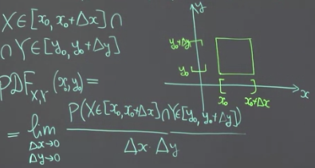

Now probability density function of X and Y is a function of two variables, x and which is defined as limit as Delta x tends to zero, and Delta y tends to zero and we are interested in the probability of getting into this rectangle. as delta x becomes smaller and Delta y becomes smaller, this rectangle becomes smaller. The probability of getting there becomes smaller. So we are interested in the relation between this probability, and the area of this rectangle, and this area is Delta x times Delta y. The above is a joint probability density function of two variables X and Y. The function of two variables can be visualized either by three-dimensional graph or by it's level curves.

Let’s use level curve to show that. The density of points in more within the central curves denoted by 2.

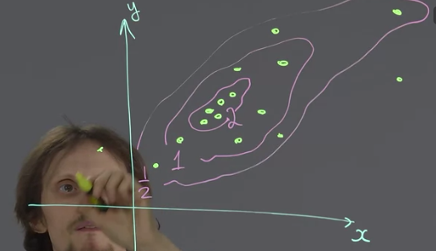

How can we get probability density function of one variable for example x? In discrete case, we had to consider a sum over all possible values of the other variable, in this case y. In continuous case, we have to replace summation by integration. So we have marginal probability

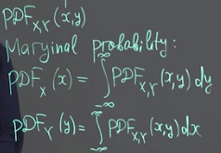

## Independence, covariance and correlation of continuous random variables

For independence

1. if their joint CDF is given by multiplication of individual CDFs
2. If they have pdf

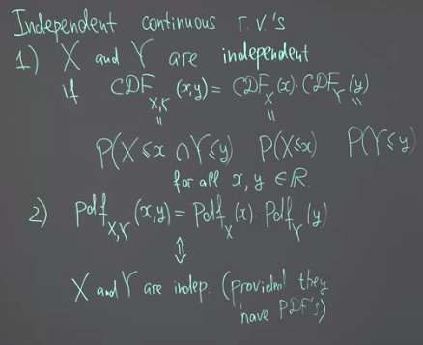

1. If they are independent then their cov and corr are equal to zero. The inverse is not true.

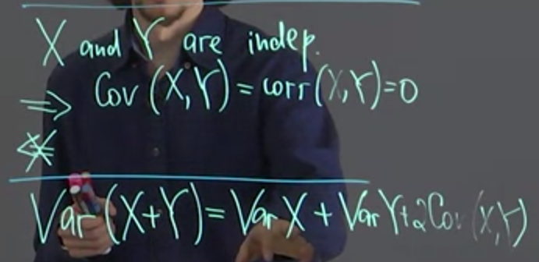

## Mixed random variables

Y equals to 0 if X is less than or equals to 0. So this probability is equal to probability that X is less than or equal to 0.

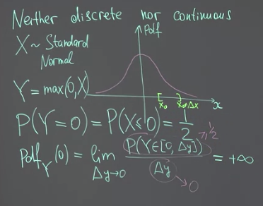

It means that probability density function is not defined at zero. On the other hand, if we consider some segment here at positive semi-axis, then here, our random variable Y coincides with the random variable X, and probability that y is inside this segment, for example from x-nought to x-nought plus Delta x, is the same as a similar probability for x.

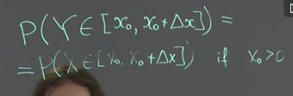

This holds if x0 positive. So we are somewhere here. It means that for that the right part of the picture, we can define probability density function for Y. This probability density function will be the same as for X. So it will be a half of a standard normal distribution, that right half.

we have a kind of different random variable that on one hand behaves like discrete random variable, and on the other hand, it behaves for different values and behaves like a continuous random variable. So we cannot define probability density function for random variable Y. However, we can define cumulative distribution function.

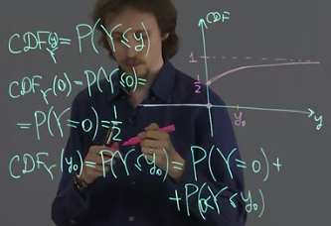

Note the Probability between 0 and y0 is calculated by integrating the pdf between those points.

# From random variables to statistical data – Week 5

We start learning statistics. Statistics deals with data, and data is usually represented in a form of table.

Descriptive statistics – the statistic does not refer to the science but to some attribute of the data.

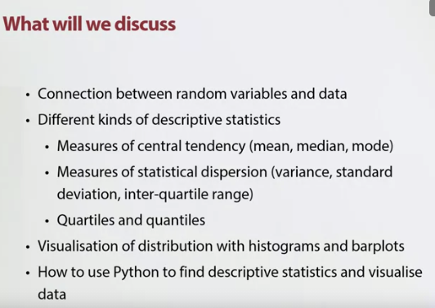

## Basic statistical model

Statistics is assigns that allows us to make conclusions about some real world phenomena, so processes or systems using some data that are extracted from this real world. However, in this real world phenomena that can be very complex and to simplify their study, we replace them with in a sense simpler mathematical models. So statistics involves some mathematical modeling. Let us discuss now the very general framework of models in statistic.

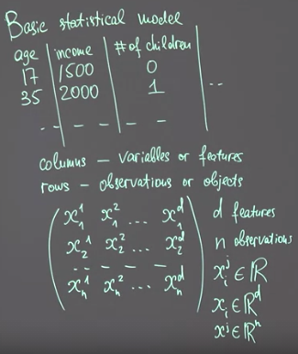

So this matrix is usually called object feature matrix where I have n rows and d features. Our model is rather simple, we have made assumption that there are several random variables or better say a system of random variables that correspond to variables of our data. Our observations are i.i.d standard for independent and identically distributed.

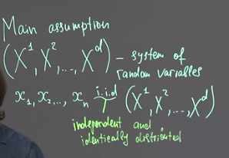

The above assumptions are our basic model. What does it mean on prospect that they are independent and identically distributed? It means that we assume that for example, income of a second person in our study does not depend on the income of the first person in our study. In the same wage income on the second person does not depend on the age of the first-person. So rows are independent of each other, but the columns can have relationship.

Identically distributed is that all rows of this table is obtained by sampling from the same population of all potential customers.

Independence is important because otherwise you get the problem we had with AML for EJ. Where one row for one account was duplicated in another account. An joint account between 16 people resulted in 16 alerts with productive alerts. When random forest saw was calculating the information gain it would calculated a larger value in favour of this alert at each node. Thus biasing the model. Noreen fixed it by over sampling other joint accounts that had fewer customers. She did not under sample because the joint account with 16 customers had more information in other columns.

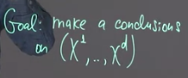

This system of random variables is also called a population, it does not mean that we have to study an actual population of some people.

## Variable types in statistics. Conversion of categorical variables to numeric

Numeric variables are of two types

* Real numbers e.g. income and weight
* Count e.g. number of children

Categorical also has two types

* Ordered e.g. level of education
* Nominal e.g. country of origin or binary numbers

We can encode categorical variables as follows,

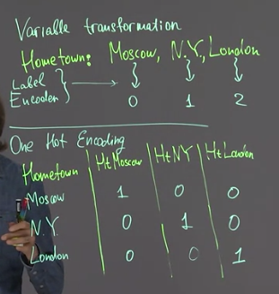

Label encoder: For some models of martial learning this is not a problem, but for some other like linear regression models, this is a problem because they assume that when they see a number, this number has the appropriate numerical meaning.

Damn encoding is just the same thing as one-hot encoding. But we remove one of the columns of their transforming data. For example this column. We can safely remove it because if we see zero here and zero here, we understand that our hometown is not Moscow and not New York and therefore it has to be London. So in this coding scheme, there is some kind of redundancy and if we remove one column, then we remove this redundancy. For some methods like linear regression, these can be important.

## Measures of central tendency. Average, median and mode

Sometimes it is important to use median and not average. For example, if we discuss incomes, for example, we discussed incomes in some country. And we understand that in this case, we have not so many people who has very large incomes and most of people doesn't have such large incomes.

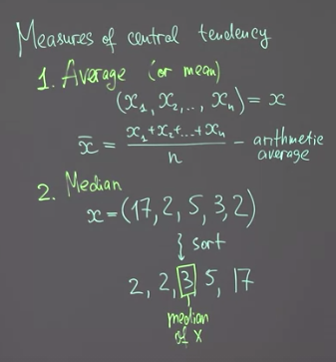

Mode is just the most frequent value that we can meet in our data set. If we have a nominal categorical variable Mode can be used to show the most occurring values.

## Measures of statistical dispersion. Sample variance, quartiles and interquartile range

Standard deviation has the same units as the variable.

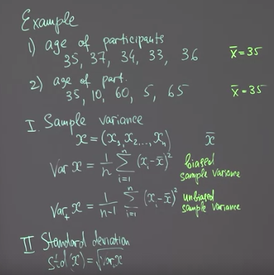

Half of the data is between Q1 and Q3 as a result the inter-quartile range can be calculated.

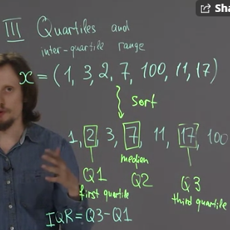

## Distribution visualization. Histograms and bar plots

Descriptive statistics that we discussed before like average or median and the corresponding deviance measures like standard deviation, give us some information about our data. But if we want to analyze the data even the one variable in details, we have to understand something about its distribution. The distribution here means that we want to understand which values are more frequent and which values are less frequent. These can be done by some visualization techniques like histograms and bar plots. Let us discuss all of them and the difference between them.

Histogram: Histograms are used to represent values of Numerical variables. First of all, we divide all range of our data into segments, something like this. Then we plot rectangles over each segment, in such a way that the height of the corresponding rectangle is proportional to the number of points in this rectangle.

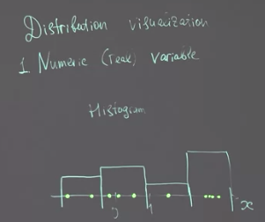

What about categorical variables. We use barplot. We can also use barplot for count data, but note that each bar represent each count value.

## Descriptive statistics of sample vs population

The values of x (sample) are sampled from random variable X (capital) – which is population.

Sample mean is related to the expected value of X i.e. we estimate the expected value using the sample average. When we increase the size of sample, whether we increase n, sample average tends to the expected value of the corresponding random variable. A similar relation can be established between a simple variance and variance of the random variable, X capital. Same applies to standard deviation.

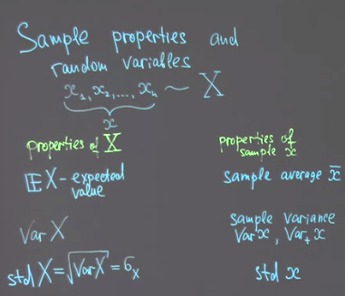

Both sample variance and unbiased sample variance tends to the variance of the random variable X. It can be used to estimate the variance of random variable X.

If we have some distribution that is given by probability density function, something like this one. Then the median is a value that divides the area under this curve, just my two-halves, this is one-half and this is another half. We can define not only median but any value that divide this area under the curve in a certain proportion. These values are called quantiles. Previously, we discussed quartiles, which are just an example of quantiles.

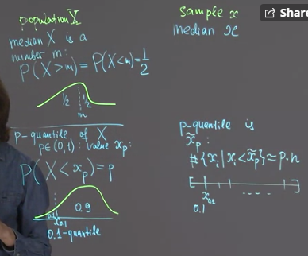

Quantiles: For population I can use the distribution and find the value of quantile, but for sample for example, if I'm interested in 0.1 quantile, I have to just sort my sample, then divide it into 10 equal parts. The border of the first part is just x_0.1. So this is 0.1 quantile.

In statistics, we use properties of sample to estimate the corresponding properties of population. This is our main goal.

# Correlations and visualizations – Week 6

## Two numeric variables. Scatter plot and levels of population's joint PDF

Assume, as we discussed before, that our data is a sample from some system of random variables. I will denote my variables now by x and y, just to shorten the notation. So age will be x and income will be y.

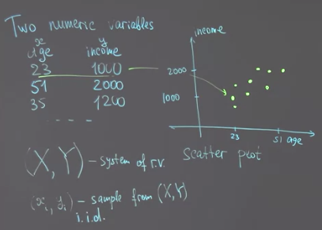

We assume that X and Y are continuous random variables. Moreover, there is a joint probability density function for this system. Then this probability density function is related to this scatter plot.

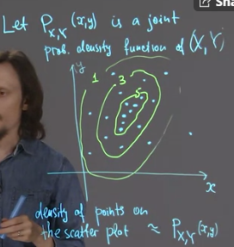

So this is so-called contour plot that allows us to imagine this probability density function for two variables. Now, if I sample my data points from this random variable, we will get a lot of points in the regions where the value of this function is large i.e. around the centre in the region of 5.

If we compare the contour plot to the scatter plot we see that they are related. Where I see more points on the scatter plot, in the same region on the pdf contour plot I see more points as well.

## Sample covariance and Pearson's correlation

Now lets discuss what type of relationship we are interested in. We are ready to discuss the notion of correlation between two numeric variables.

Lets consider 4 examples, some correlations are strong others are week.

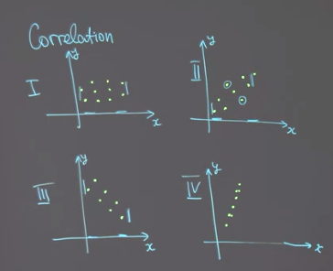

We want to develop a formula that will give us the strength of correlation, so we start with covariance.

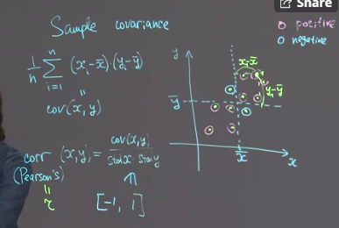

The pink color circle denote positive contribution because x-xbar and y-ybar multiplied will result in positive values. This could lead to large covariance when the negative contributions are small.

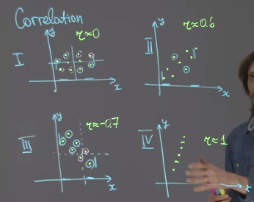

The pearson’s correlation, denoted by r, is simply covariance divided by std of x and y. Now if covariance is large and the std of x and std of y are small then this correlation will be large.

## Correlation vs causation

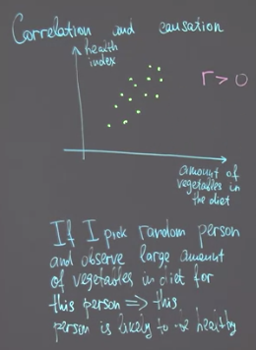

large amount of vegetables in diet for this person, I can conclude that this person is healthy. So this interpretation is correct, but note that this is a purely observational setting. We pick somebody random, we observe one variable, and we make a conclusion about another variable. If we wanted to give an advice we have to consider a little bit different question, we have to say if a particular person switch from low level of vegetables in their diet to high level of vegetables or vice versa, how it will change their index. To answer this question I have to take into account possible causal relationship between these vegetables and this health index, which are not covered by just this correlation. Indeed, this picture can be explained in different ways, the first way which is possible is that the large amount of vegetables is a reason for large health index. So in this case we can say that vegetables act on health.



The second interpretation is that our participant first chooses their lifestyle, it can be more healthy or less healthy, for example if this person choose a healthy lifestyle they eat more vegetables, but also they do some sport, or they visit doctors often and so on. So they are interested in their health, in this case it is possible that healthy lifestyle itself acts on the health index. vegetable consumption in this case is just a proxy for healthy lifestyle, but it does not change the health itself, it just gives us information about the lifestyle.

No correlation can distinguish between these two possible explanations, so we cannot use correlation to make causal conclusions unless we are assured that there is a relation like this one. Therefore, we need to do causal analysis.

## Rank correlations for non-linearly dependent data and ordered categorical data – Kendall’s tau

If your data has a non-linear correlation or you have outlier than the pearson’s correlation will not provide accurate measure of correlation. Take the following two example, the first one has a perfect correlation but it is non-linear.

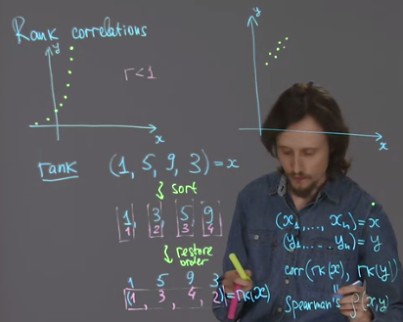

The pink numbers are called the sequence of ranks or original numbers. This is what rank transformation does. rk stands for rank. We take rank of x and rank of y. we then get the correlation of these ranks. And this is called spearman’s correlation.

Lets find the rank correlation of the first example. As we can see rx and ry are perfectly correlated.

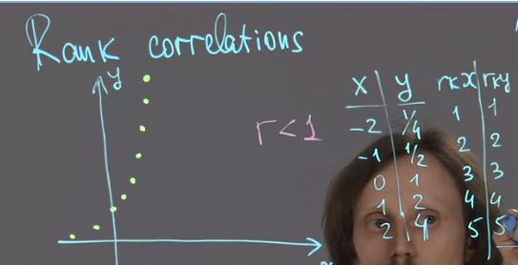

Lets consider the second example with outlier.

First, for a pair of points, we call this kind of points concordant. And this pair of points discordant. Concordant means that for larger value of x we have larger value of y. And for discordant, for larger value of x, we have lower value of y. Then we consider our data set and we consider all possible pair of points in this data set.

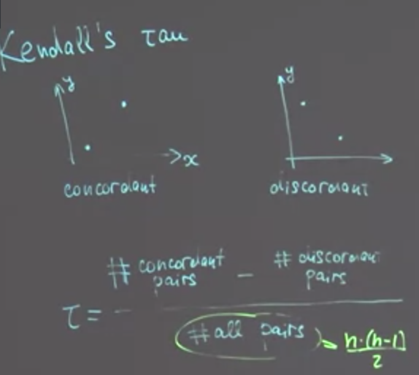

We find number of concordant points. Concordant pairs. Subtract number of discordant pairs. And divide it by the number of all possible pairs. This relation is called kendall’s Tau. Now if the discordant points are very few then tau will be close to 1, which means good correlation.

When finding correlation use:

* Pearson’s
* Spearsman’s
* Kendall tau

And where the variables are categorical see if they can converted to numerical as follows.

